Solution: Assignment - 1

Q. 1: Consider the circuit shown in Figure 1. Perform nodal analysis and hence determine V_{A}, V_{B}, V_{C}. Also determine the power delivered by the current source.
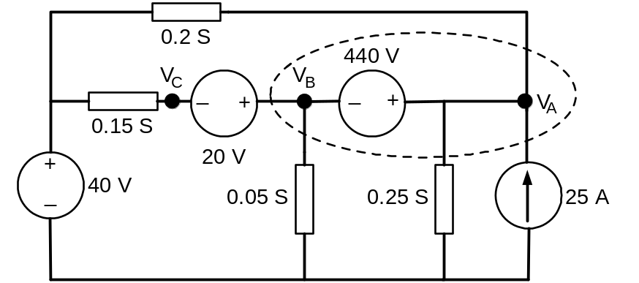
Figure 1
Since there is a voltage source between nodes A and B, a super-node is formed by combining the two nodes giving following equations:
(1)
By applying KCL to super-node:
(2)
(3)
Substituting (1) in (3),
Using (1),
Also,
Power delivered by current source is,
Q2:
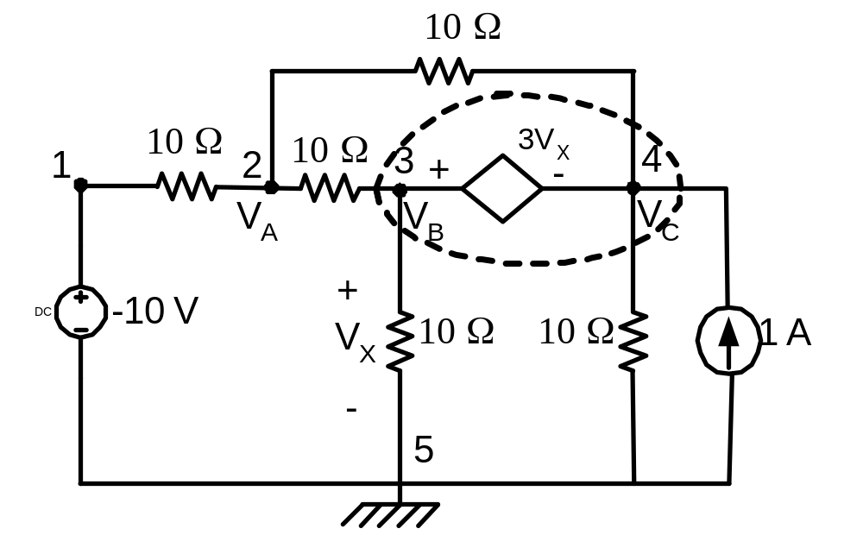
From the above figure, nodes 3 & 4 are super nodes
Applying KCL at node 2:
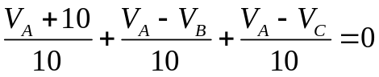
Simplifying the above equation
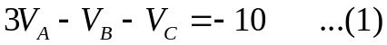
Applying KCL at super node having 3 & 4 as internal nodes
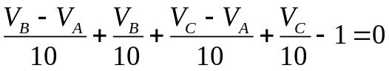
Simplifying the above equation
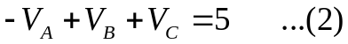
From the super node, it can be written as
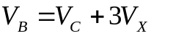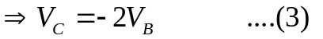
Substituting (3) in (1) & (2) and solving

Q3:
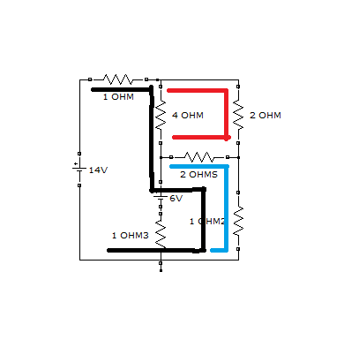
The black coloured line represents loop1,
The red coloured line represents loop2 and,
Similarly, the blue coloured line represents loop 3.

By applying KVL in the three loops
14 – (i1) *1 – (i1 – i2)*4 – (i1 – i2 + i3) *2 – (i3 + i1) *1 = 0 (EQU-1)
- i2* (2) – (i2-i1-i3)* 2 – (i2- i1)*4 = 0 (EQU-2)
6 – (i3 + i1 – i2)*2 – (i3 + i1)*1 – i3*(1) = 0 (EQU-3)

Simplifying the above three equations
14 – 8*i1 + 6*i2 – 3 *i3 = 0
6* i1 – 8*i2 + 2*i3=0
6 – 3*i1 + 2*i2 – 4*i3 = 0
Solving the above three equations we get
i1 = 4
i2 = 3
i3 = 0

Q 4
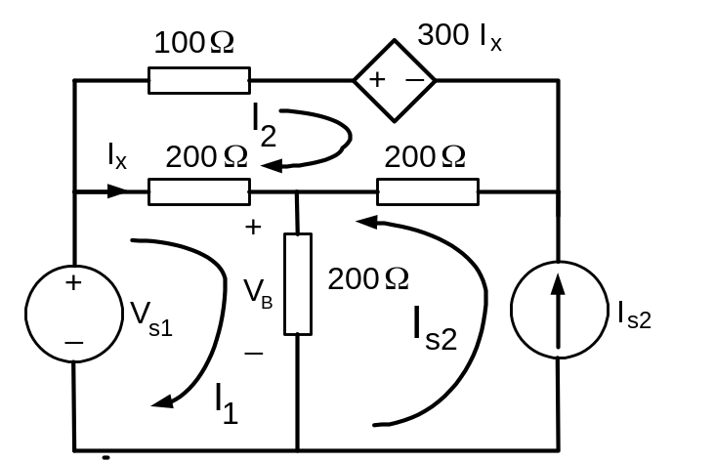

KVL of loop -1
KVL of loop -2
Or

On solving of equations (1) and (3) we get

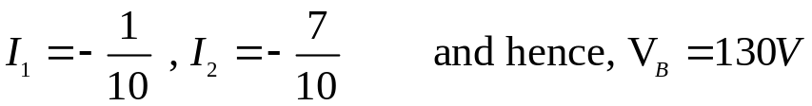

Q5)
As the network is linear,
(Where A and B are constants)
Experiment 1:
,
(1)
Experiment 2:
,
(2)
Solving (1) and (2),
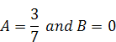
(i.e., I_{load} is independent of I_{b)}

Thus,
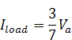
Hence,
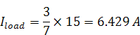

Q6. Find the Thevenin equivalent circuit of the network shown in Figure 6 as viewed from A – B.
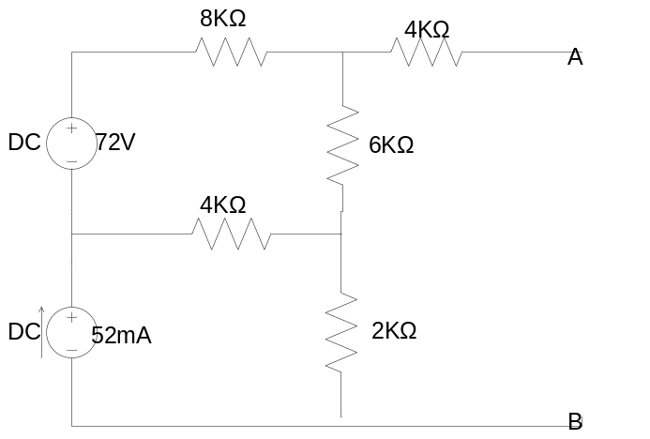
Figure 6
Thevenin Equivalent Resistance (R_{th)}:
To find equivalent Thevenin equivalent resistance of circuit, ideal voltage source represented with short and ideal current source with open and corresponding equivalent shown in Figure 1
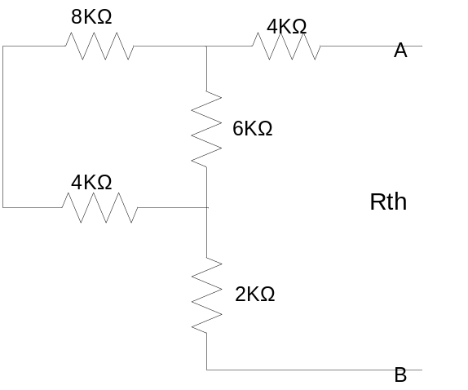
Figure 1
R_{th} = 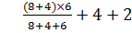 = 10KΩ

Thevenin Equivalent Voltage (V_{th}):
Considering Voltage source alone the equivalent circuit to find V_{th1} is
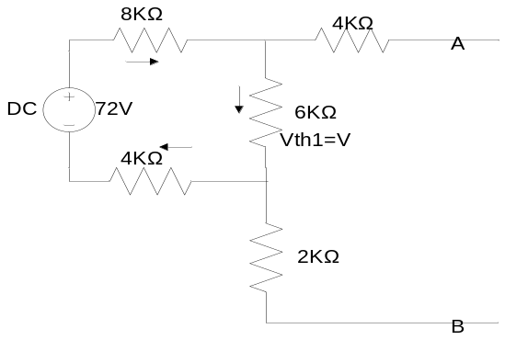
V_{th1} = 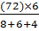 = 24V
Considering current source alone the equivalent circuit to find V_{th2} is
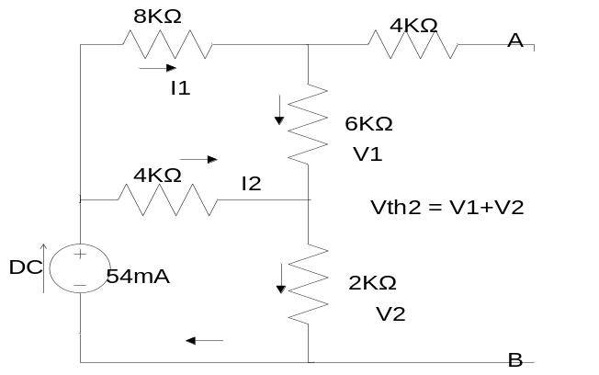
I₁ ₊ I₂ = 54mA
I₁ = 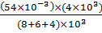 = 12mA
V₁ = 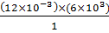 = 72V
V2 = 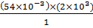 = 108V
V_{th2} = V₁ + V₂ = 72+108 = 180V
V_{th} = V_{th1} + V_{th2} = 24 + 180 = 204V.

Thevenin equivalent circuit is
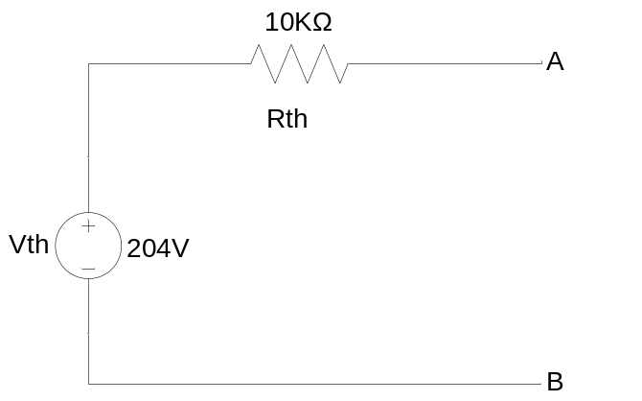
Q7
Since there are no independent internal sources, V_{OC}=I_{SC}=0 and the Thevenin equivalent consists of a single resistance R_{th}.
Step1: to find R_{th.}
Because of the presence of the dependent sources, R_{th} cannot be calculated by series-parallel combination of resistances and R_{th}= cannot be used either. By attaching a fictitious external voltage source V_{S}, R_{th}=.The objective is to compute Is and obtain R_{th}. To simplify the equation, we set V_{s}=1V.
Step2: Applying nodal analysis.
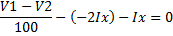
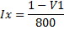
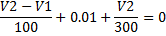
By solving eq. (1) & (2) V1=-7V, Ix=, Rth= 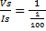=100 Ω
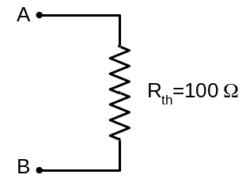
Q 8
To find Thevenin Voltage:
When terminals A and B is open, no current flows through 6-ohm resistor.
I₁ = 3A
Apply KVL in the loop consisting of 6 ohms, dependent voltage source and 10 ohms

V_{AB} = 10 x 3- 4 x 3 = 18 V

To find Norton Current:
If we short terminals A and B and apply KCL at the junction where the independent current source, 10-ohm resistor and dependent voltage source meet

3 = I₁ + (10 * I₁ - 4 * I₁) / 6

I₁ = 1.5 A
I_{sc} = 1.5 A

To find R_{th}
R_{th} = V_{th} / I_{sc} =18 / 1.5 =12 ohm
solution is
V_{Th} = 18 V
R_{th} = 12 ohm
I_{N} = 1.5 A
Q. 9
To find R_{th}
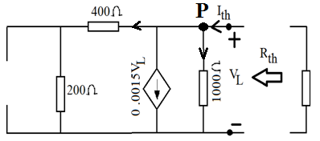
Applying KCL at point P,
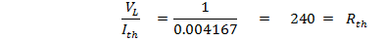

To find V_{th}
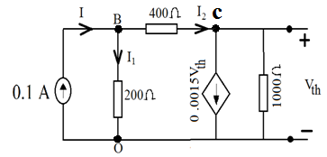
Applying KCL at point c,
The voltage drop across 200 ohm resistor is,
Or,
Now, =
Applying KCL at point B,

Now, maximum power will be transferred to R_{L} when its value is R_{th}. So, for this condition the Thevenin equivalent circuit is,
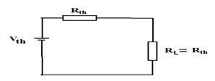
The maximum power delivered to the load is,
watt

